
LAB 9
LAB TASKS

name: saqba yasmin
Sap id: 63476
Submitted to: Mam Rehana Sanam

Task 1:
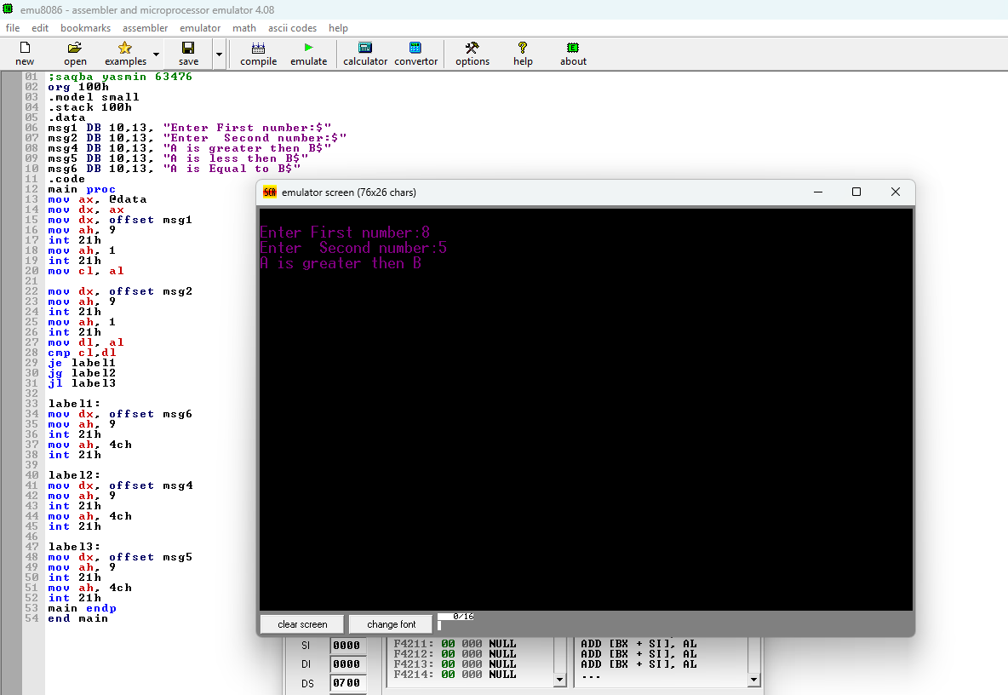

Task 2:
